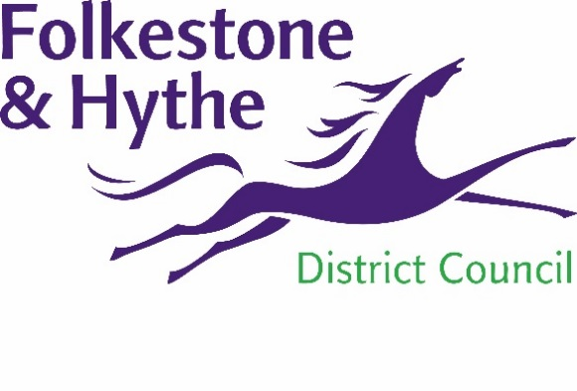
NEWS RELEASE

4 March 2021

Ecological work begins by the Royal Military Canal

Work has begun to improve the ecology of the northern bank of the Royal Military Canal for reptiles, bats and birds.
The work, recommended by ecologists, is part of the plan for Folkestone & Hythe District Council to carefully manage the wildlife of the Royal Military Canal long-term as part of the Princes Parade development.
Council officers are removing dense vegetation – including dead trees and invasive weeds – to create a better environment for certain species of wildlife. The work has been carefully timed to minimise the effect on nesting birds later in the season.
To enable this work to take place sections of footpath alongside the canal will have to be temporarily closed. Disruption will be kept to a minimum with alternative routes clearly marked with signage.
Cllr David Monk, Leader of Folkestone & Hythe District Council, said: “We appreciate the inconvenience these footpath closures may cause and we’ll make sure alternative routes are clearly marked.
“Vegetation is being removed to encourage grassland so – as with many landscaping changes – the area affected may look sparse initially. However, the less this is disturbed the quicker the new shrub and grassland will be established. I want to thank residents for their patience while we complete these works”.
All works are scheduled to be completed within a few weeks.
For more information about the Princes Parade scheme please visit folkestone-hythe.gov.uk/princesparade

ENDS

For more information, please email communications@folkestone-hythe.gov.uk

To keep up to date with the latest council news:

Follow us on Facebook: @FolkestoneandHytheDC
Follow us on Twitter: @fstonehythedc
Follow us on Instagram: @folkestonehythedc
Follow us on LinkedIn: Folkestone & Hythe District Council

